
SUBMITTED BY:
FATIMA ABBAS __ 2025_CYS_07
ASSIGNMENT:
PACMAN_GAME
SUBMITTED TO:
SIR SHAHMEER NAWAZ
FOR THE FULFILLMENT OF:
OBJECT-ORIENTED PROGRAMMING LAB
DEPARTMENT OF COMPUTER ENGINEERING
UNIVERSITY OF ENGINEERING AND
TECHNOLOGY, LAHORE.

CEP Description
Create a Pacman game using OOP that involves the use of multiple classes and objects that interact with each other. The PackmanGame class contains the main method and initializes the game by creating instances of the GameBoard, Pacman,
Ghost, and Food classes. The PacmanGame class also contains the game loop and handles user input, allowing the player to control Pacman's movement around the board.
JAVA CODE:
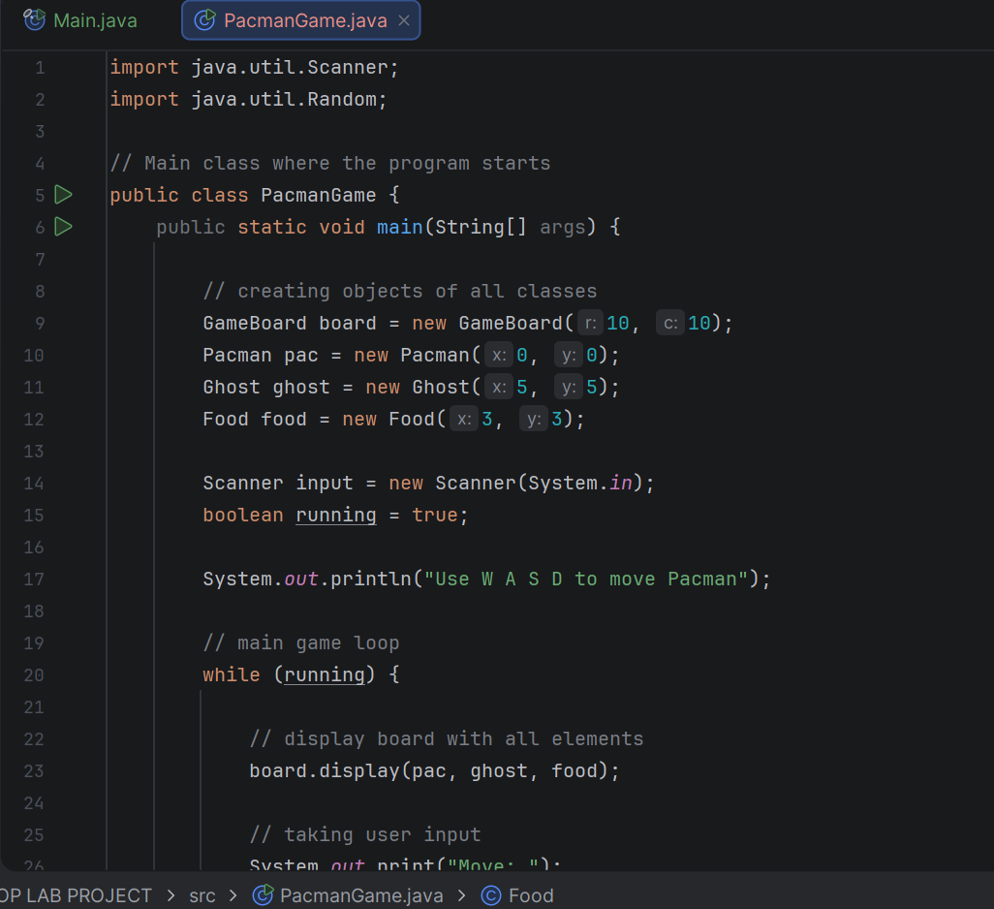
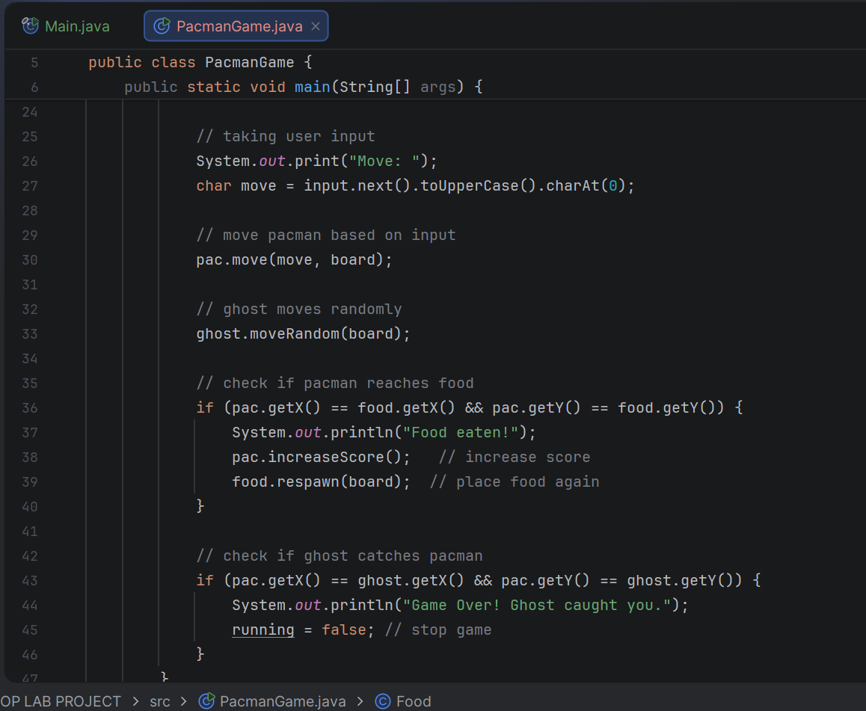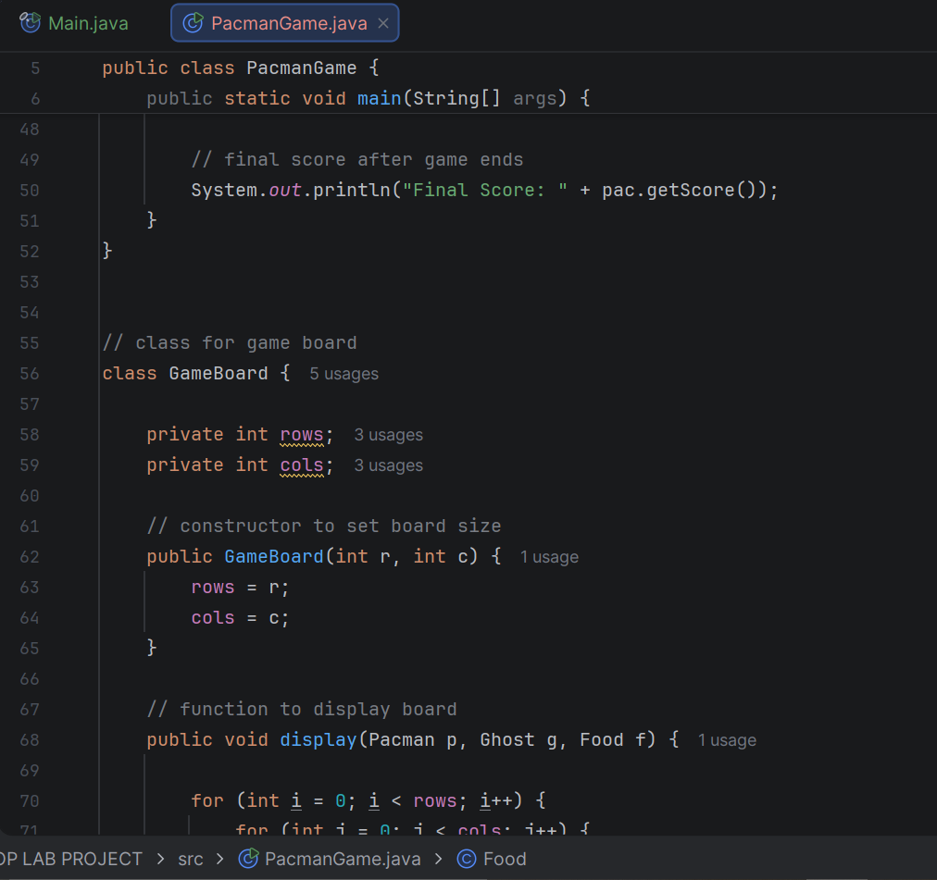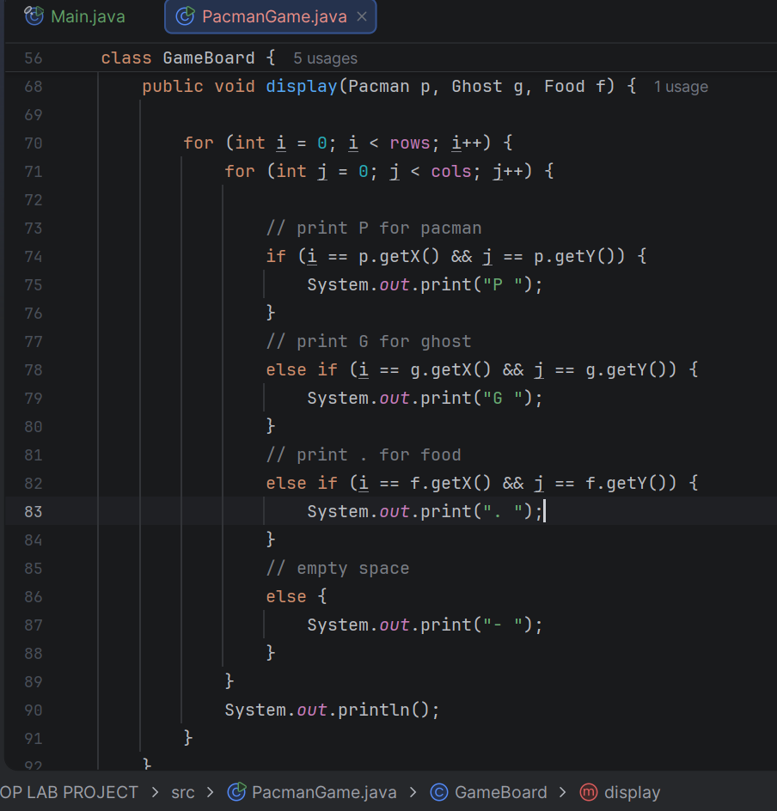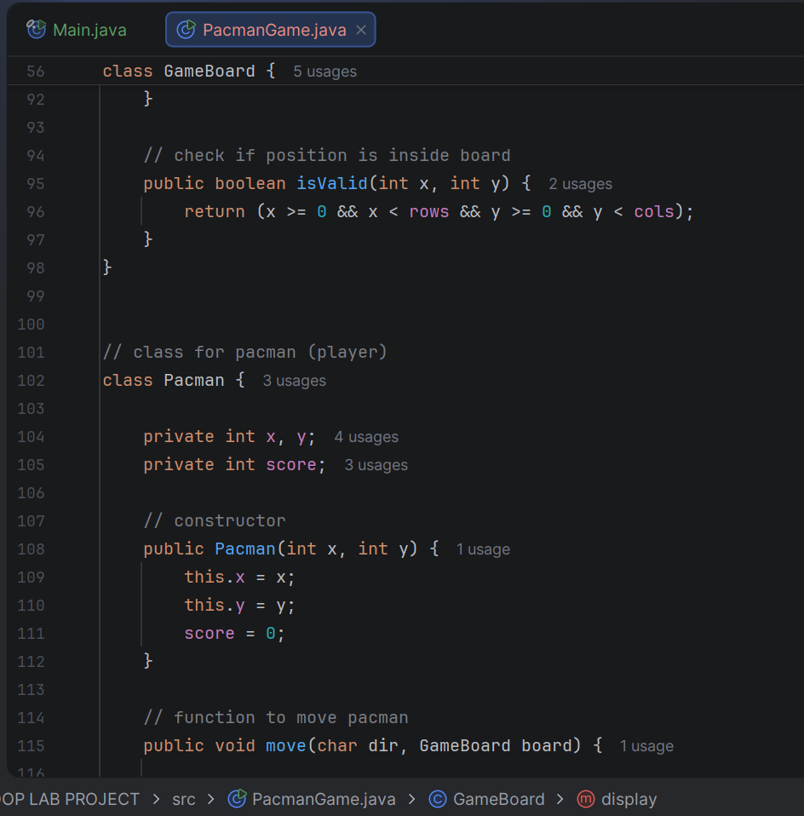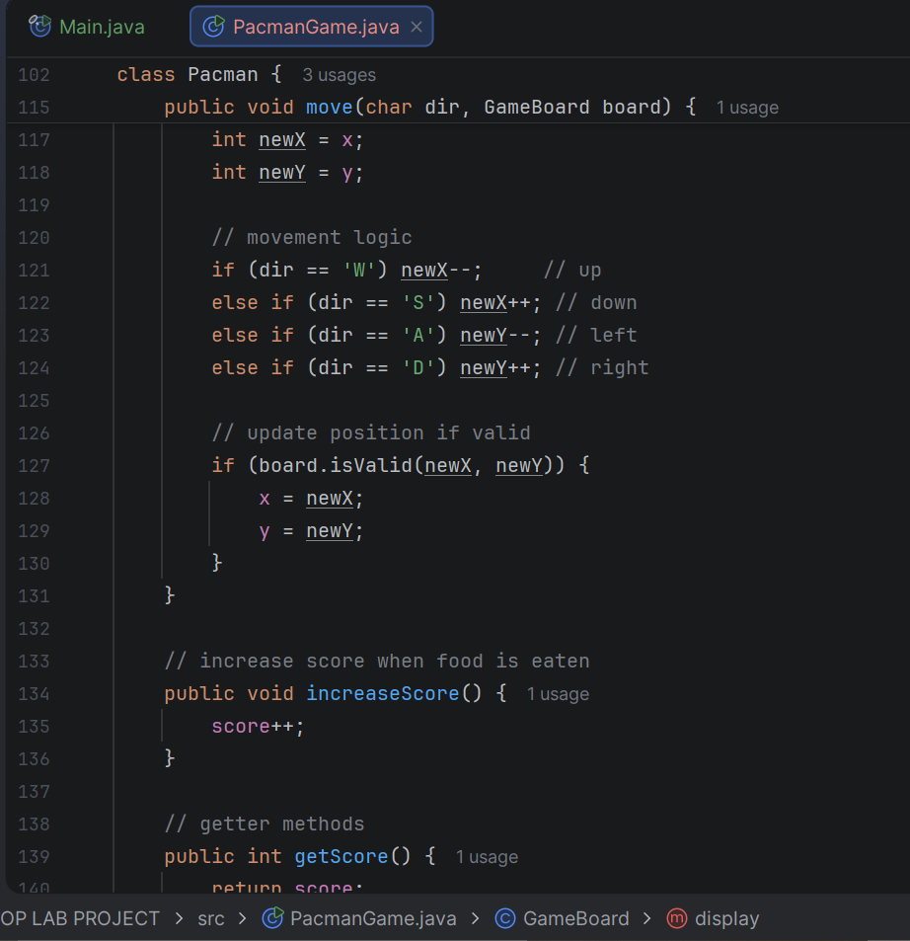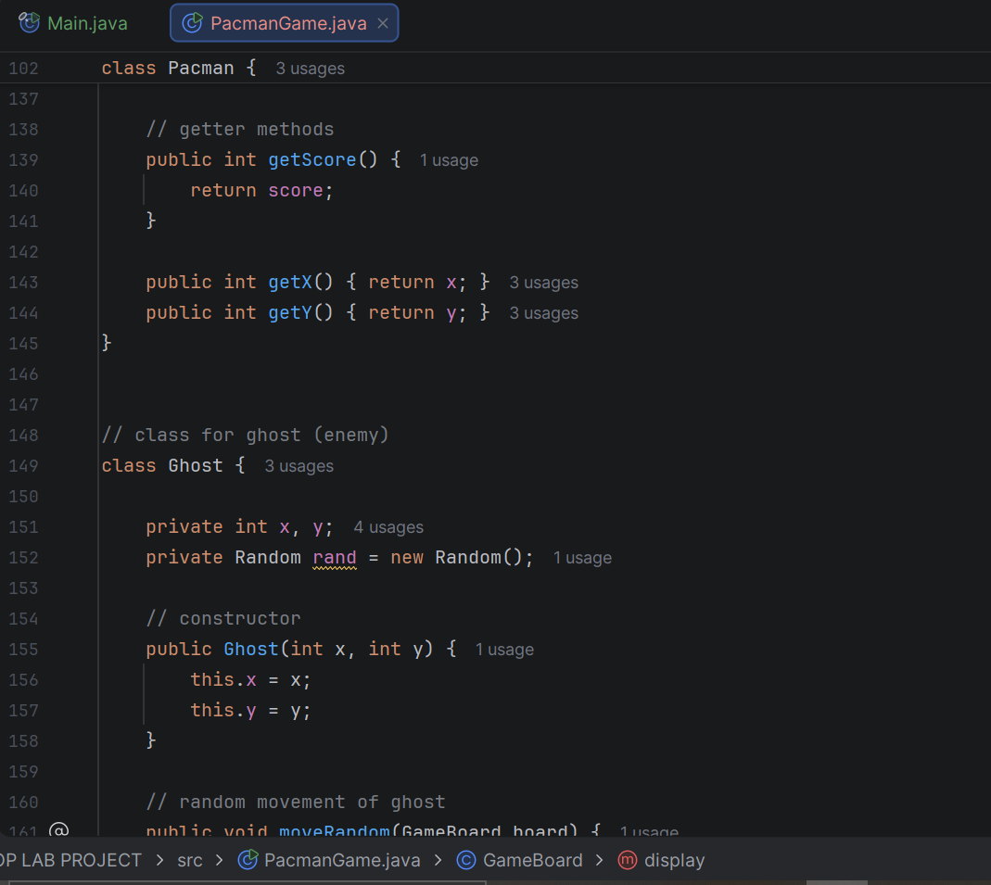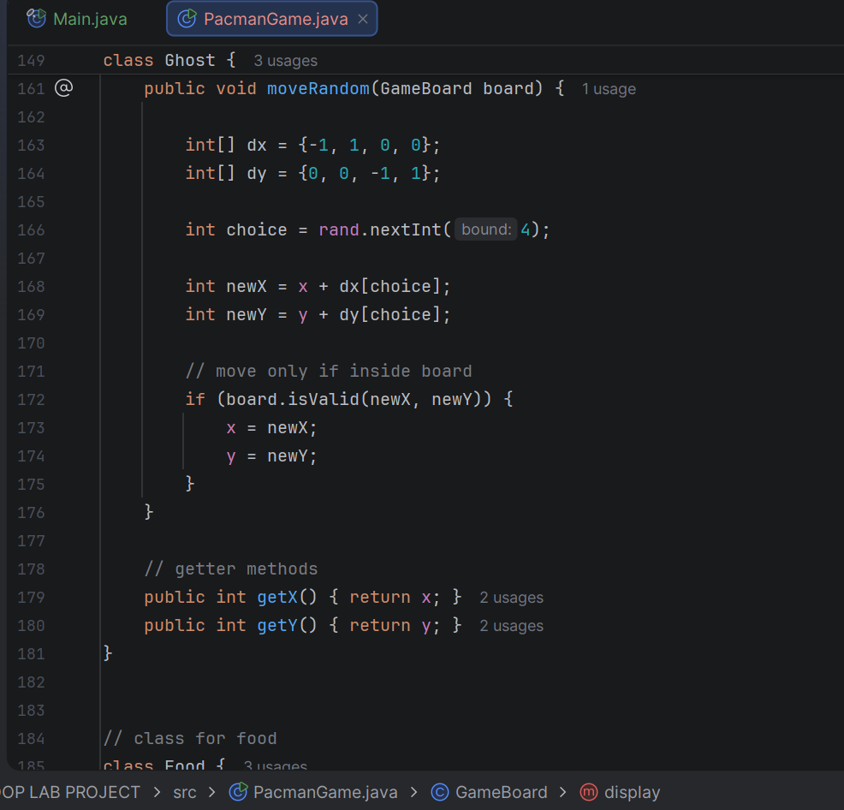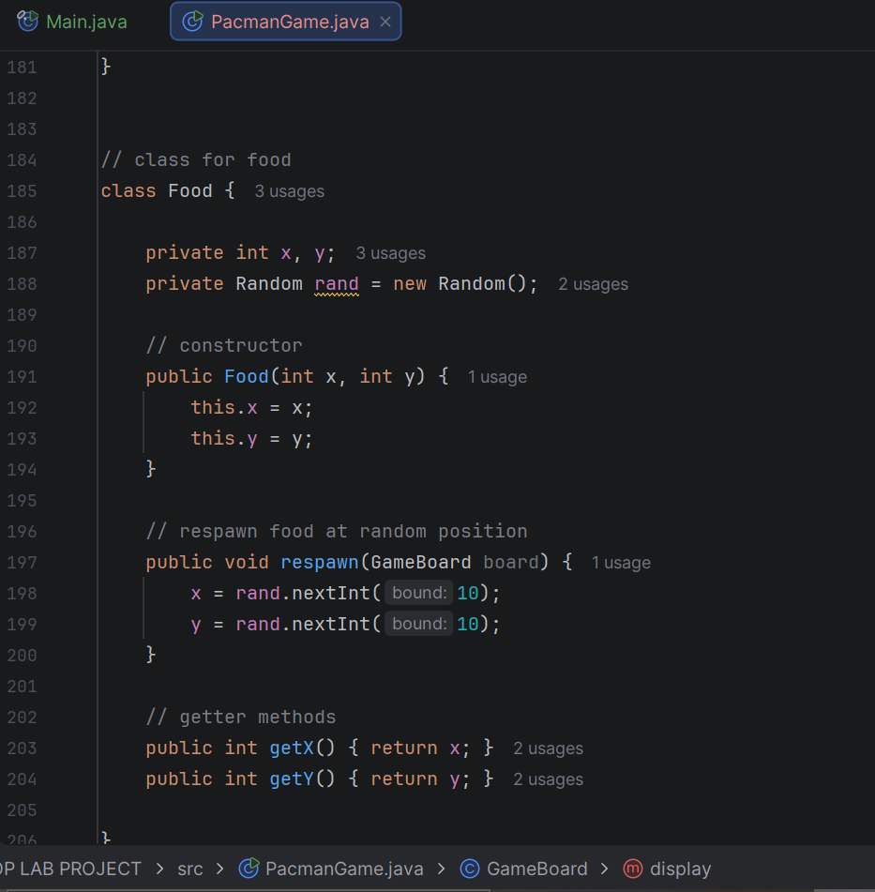

OUTPUT:
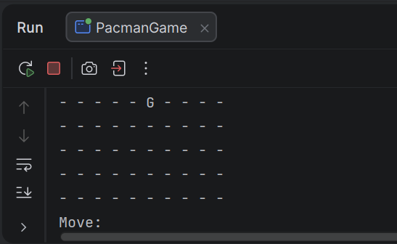

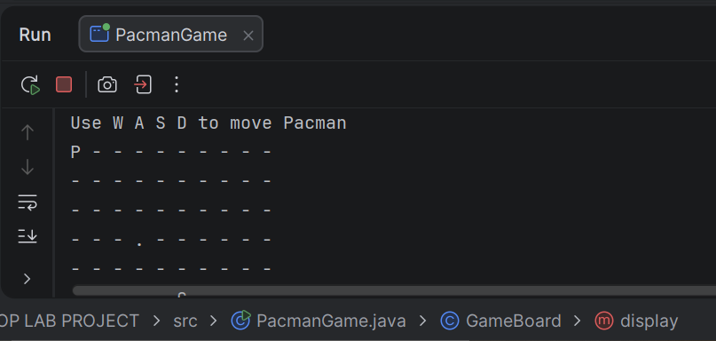
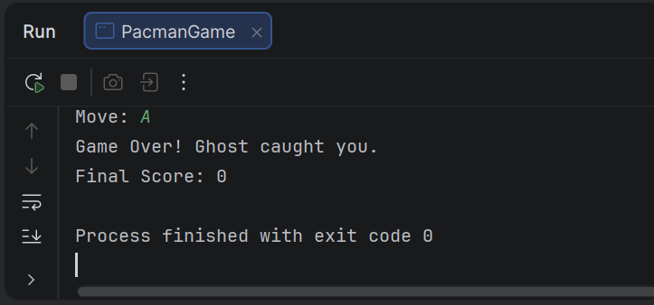

REPORT:

Pacman Game Using Object-Oriented Programming (OOP)

1. Introduction
This project is based on the development of a simple Pacman game using Object-Oriented Programming concepts in Java. The main goal of this project is to understand how classes and objects interact with each other in a real-world scenario like a game.
The game is console-based and allows the user to control Pacman using keyboard inputs. The game continues until Pacman is caught by the ghost.

2. Objectives
- To implement OOP concepts such as classes and objects
- To understand interaction between multiple classes
- To create a simple game using Java
- To handle user input and game logic

3. System Design
The project consists of the following main classes:

1. PacmanGame (Main Class)
- Contains the main method
- Initializes all objects (GameBoard, Pacman, Ghost, Food)
- Controls the game loop
- Takes user input and updates the game

2. GameBoard Class
- Represents the game grid
- Displays the board on the console
- Checks whether a move is valid or not

3. Pacman Class
- Represents the player
- Stores position (x, y) and score
- Handles movement based on user input

4. Ghost Class
- Represents the enemy
- Moves randomly on the board
- Ends the game if it collides with Pacman

5. Food Class
- Represents food items
- Increases score when eaten
- Respawns at a new random location

4. Working of the Game
- The game starts by initializing the board and placing Pacman, ghost, and food.
- The board is displayed on the console.
- The player enters a move using W, A, S, or D keys.
- Pacman moves according to the input if the move is valid.
- The ghost moves randomly after each turn.
- If Pacman reaches the food, the score increases and food respawns.
- If the ghost reaches Pacman, the game ends.

5. OOP Concepts Used
- Encapsulation: Each class contains its own data and methods
- Abstraction: Only necessary details are exposed through methods
- Objects & Classes: Multiple objects interact with each other
- Modularity: Code is divided into separate classes for better organization

6. Sample Output
P - - - - - - - - -
- - - - - - - - - -
- - - . - - - - - -
- - - - - G - - - -
Controls:
- W → Up
- A → Left
- S → Down
- D → Right

7. Limitations
- No graphical interface (console-based only)
- Only one ghost is present
- Ghost movement is random
- No levels or difficulty increase

8. Conclusion
This project helped in understanding the practical implementation of Object-Oriented Programming concepts. It demonstrates how multiple classes can work together to create a simple interactive game. The project can be further improved by adding more features such as graphics, multiple enemies, and levels.

9. Future Improvements
- Add graphical user interface (GUI)
- Introduce multiple ghosts
- Add levels and difficulty
- Improve ghost movement using AI

ARCHITECTURE DIAGRAM:
The architecture of the Pacman game is based on object-oriented design principles. The Game class acts as the controller, managing interactions between Pacman, Ghosts, Maze, and Score system. Each class is responsible for its own behavior, ensuring modularity and reusability.

